Jurnal Percobaan SSB-AM
- Mengetahui karakteristik dinamik SSB
- SSB
Tabel 9
Amplitudo | Frekuensi | Gambar
2 | 2 kHZ | 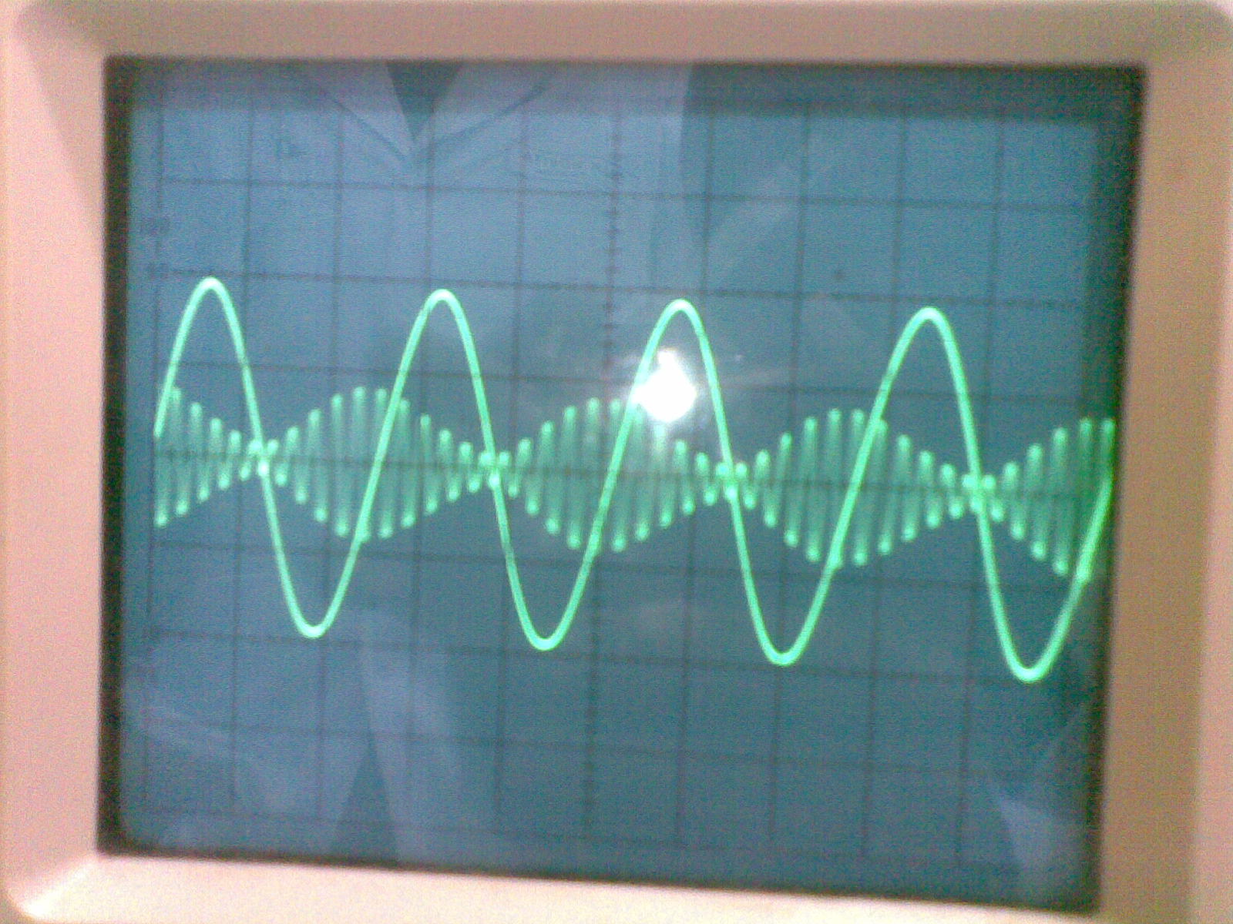
2 | 3 kHZ | 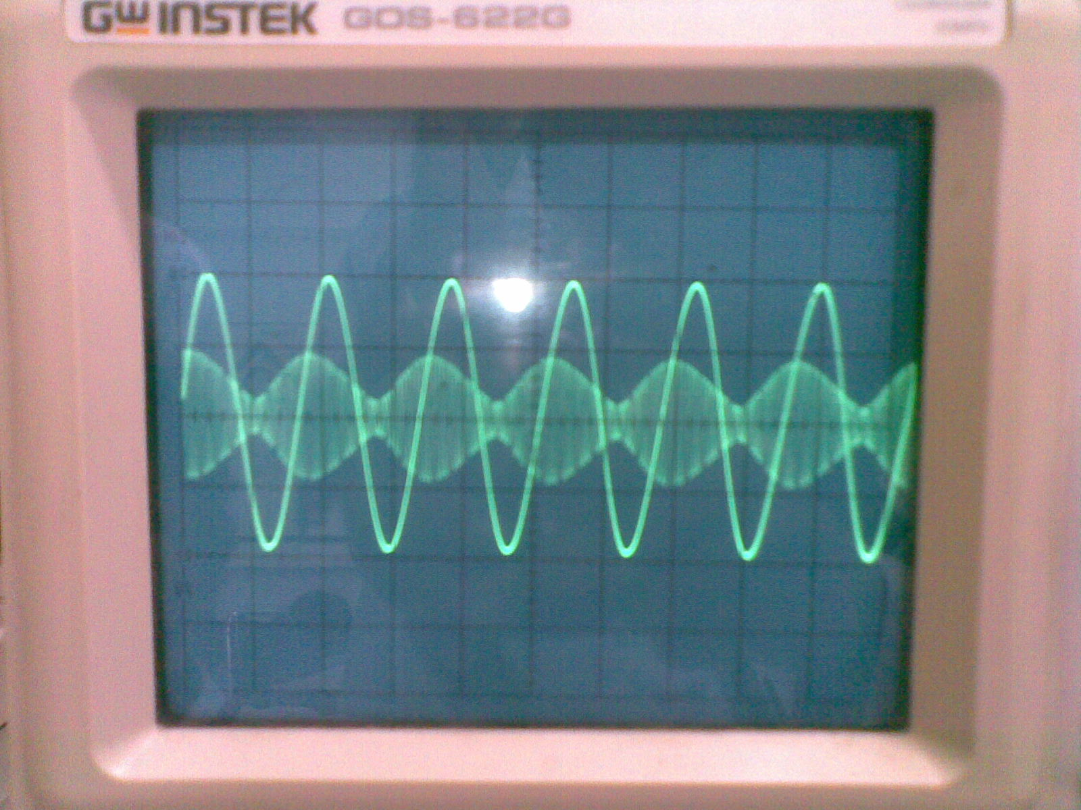
3 | 2 kHZ | 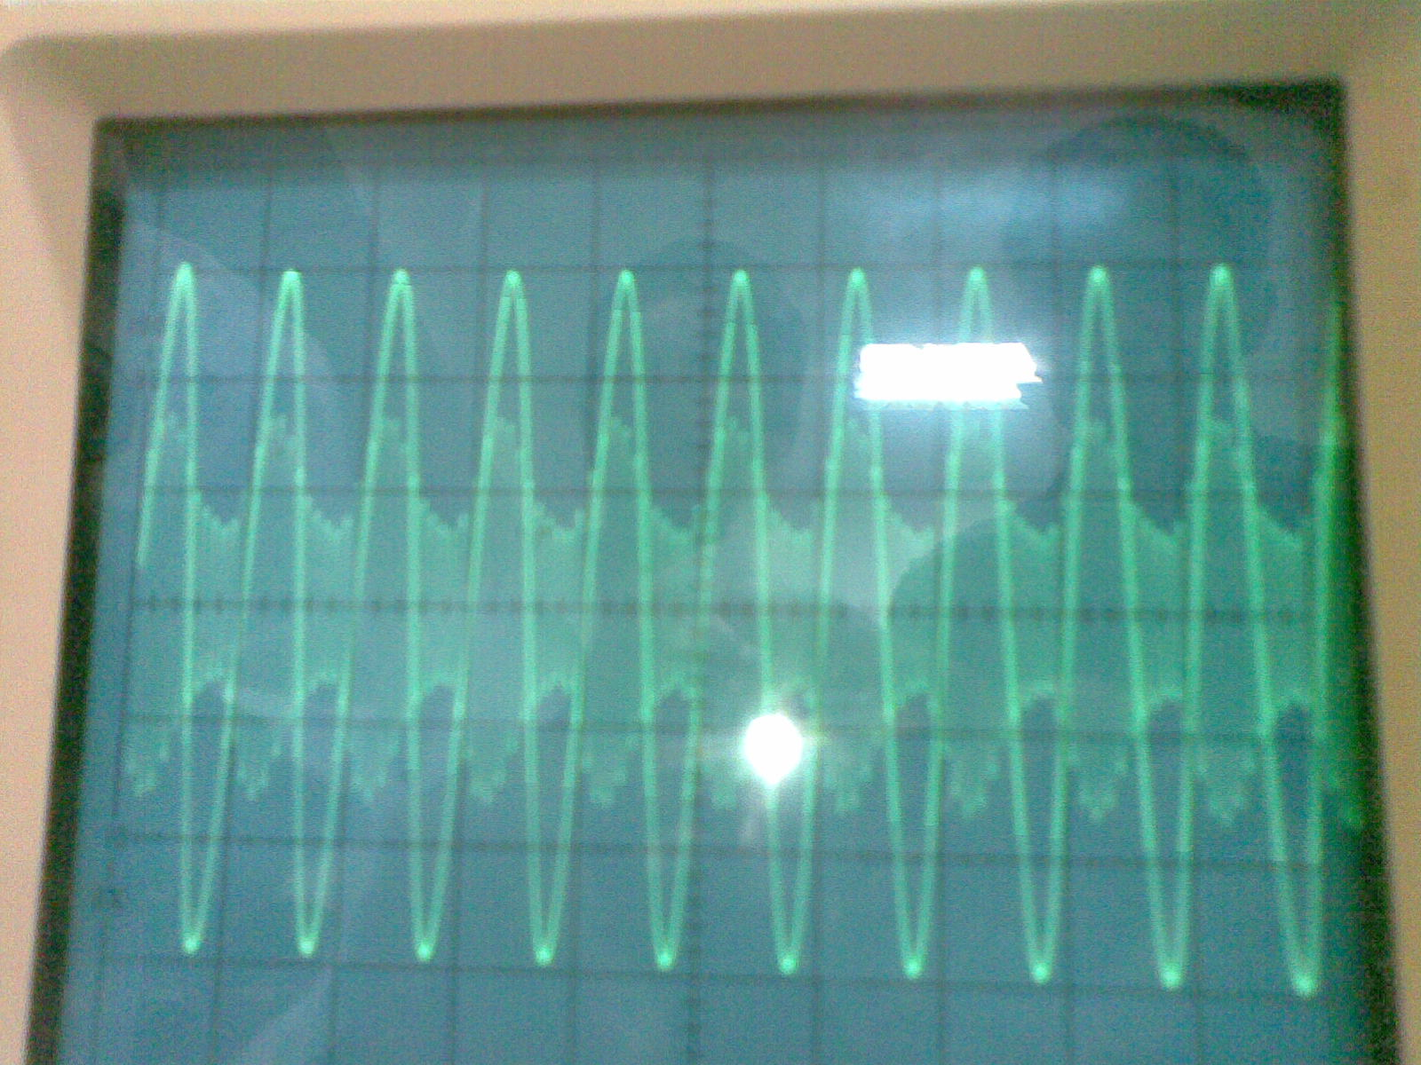
1 | 2 kHZ | 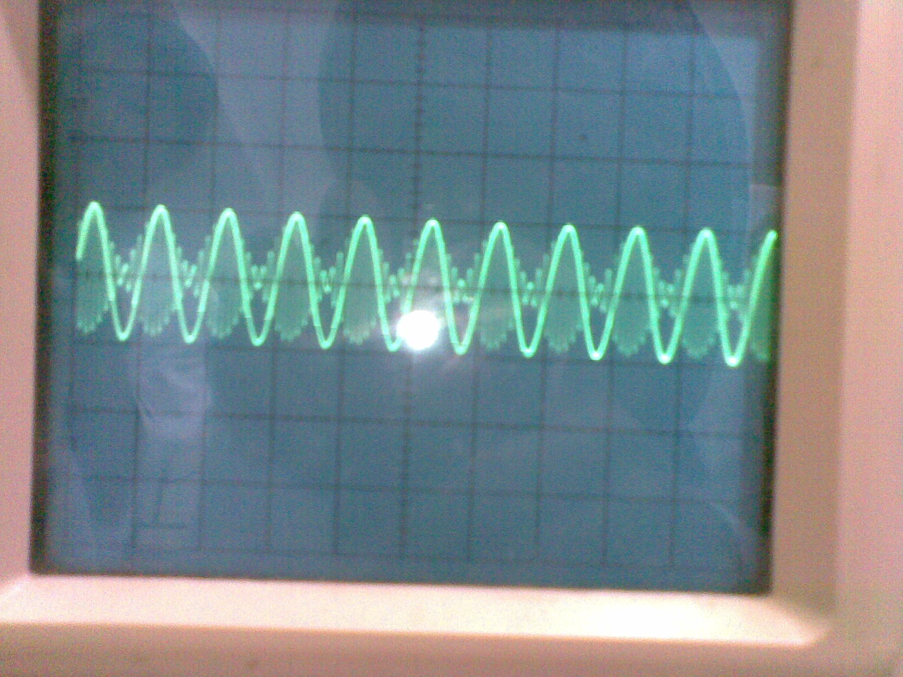
2 | 1 kHZ | 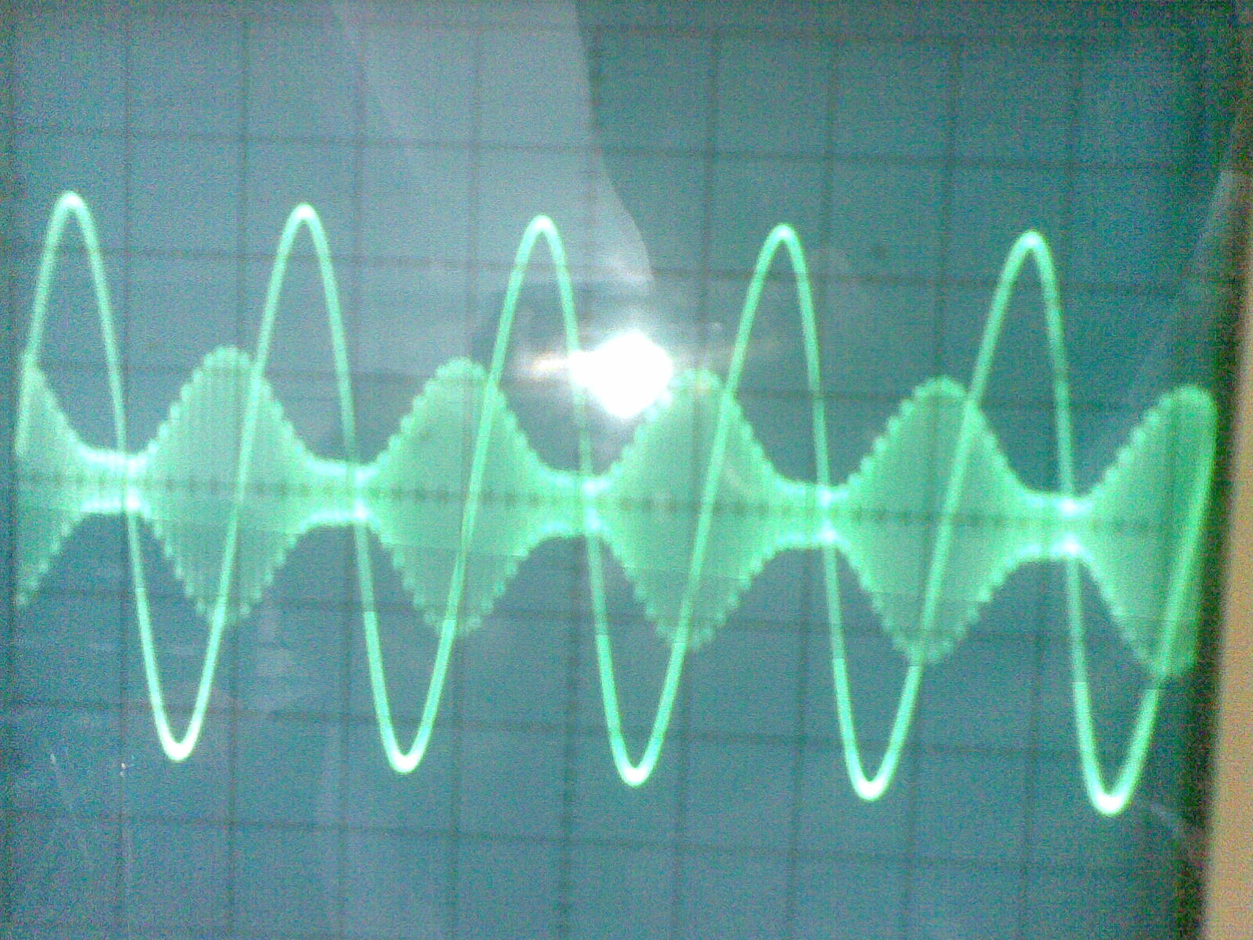
Tabel 10
percobaan | Fm | Am | $∆$Ac | Ac | m
1 | 2 | 2 | 1 | 1.6
2 | 3 | 2 | 1 | 1.6
3 | 2 | 3 | 1 | 1.6
4 | 2 | 1 | 1 | 1.6
5 | 1 | 2 | 1 | 1.6
- SSB-SC
TABEL 11
Amplitudo | Frekuensi | Gambar
2 | 2 | 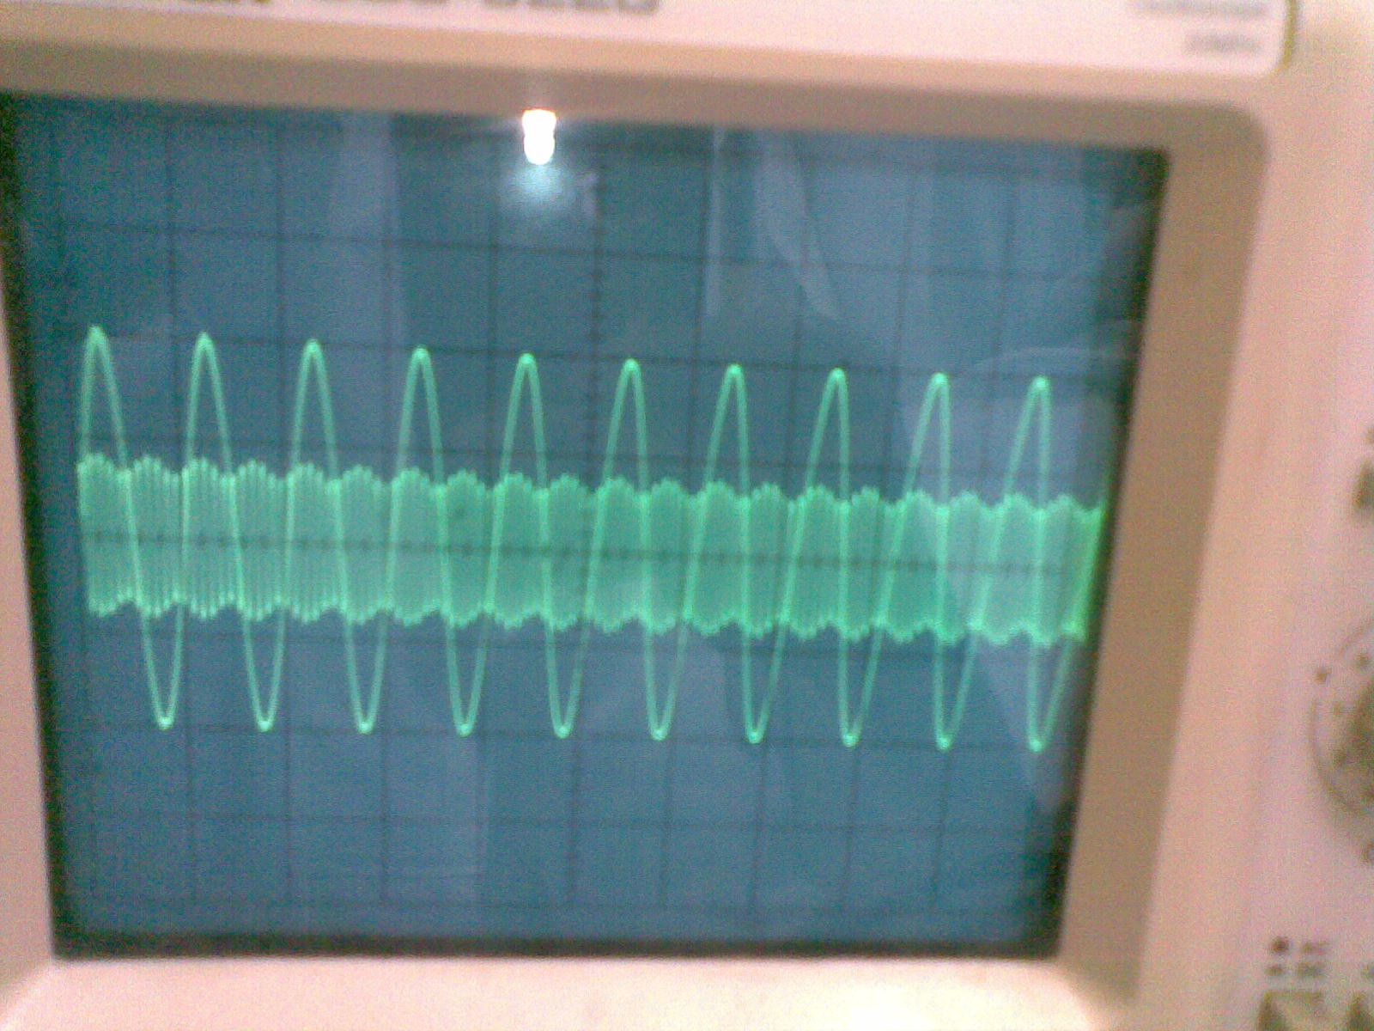
2 | 3 | 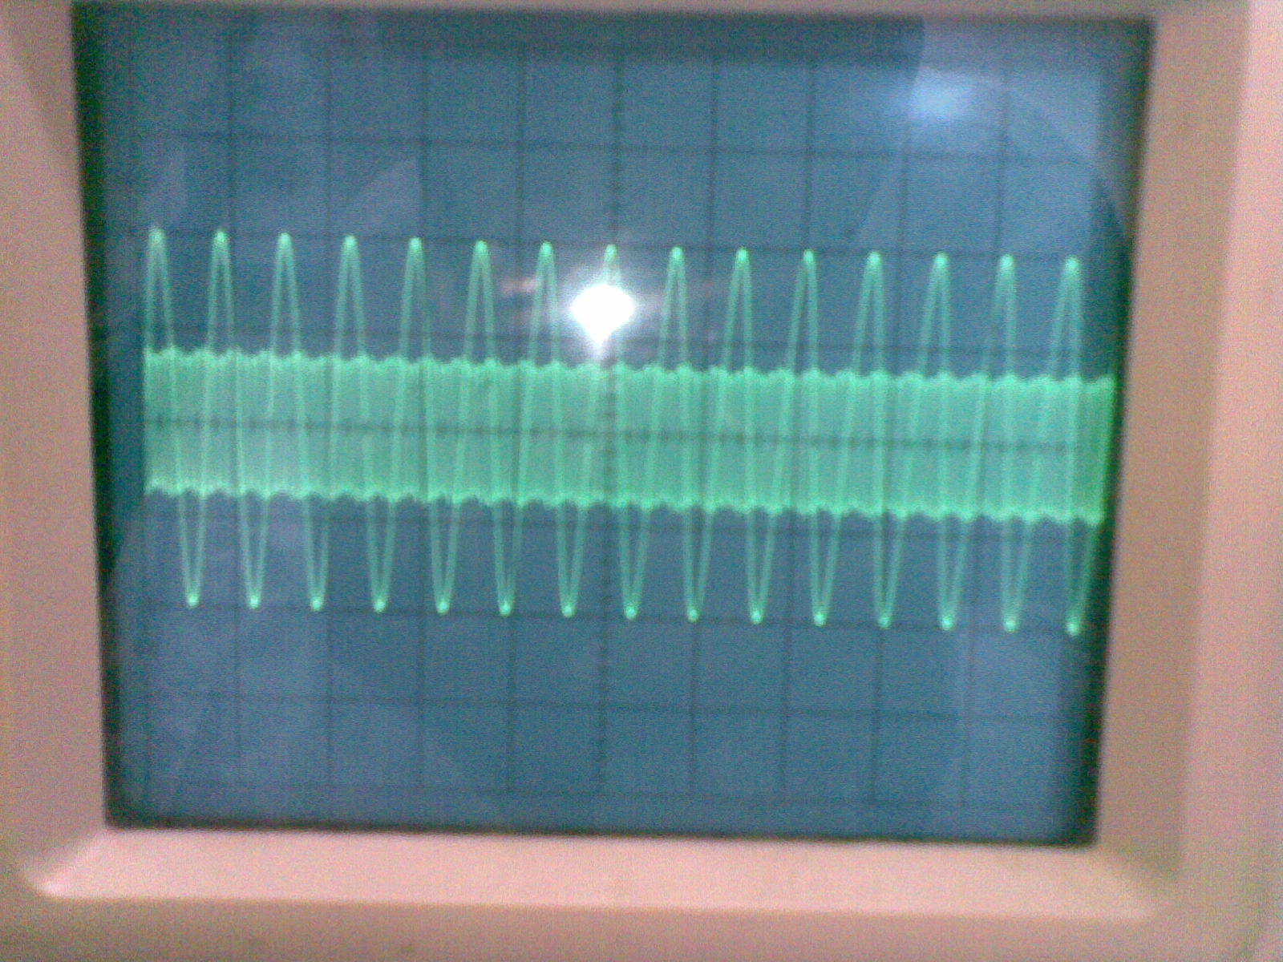
3 | 2 | 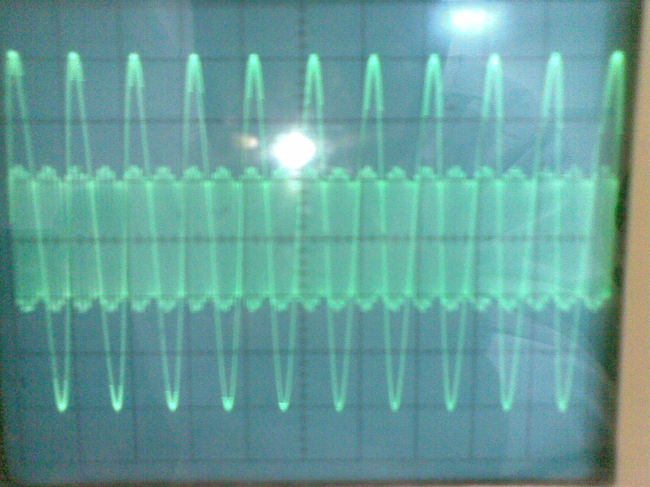
1 | 2 | 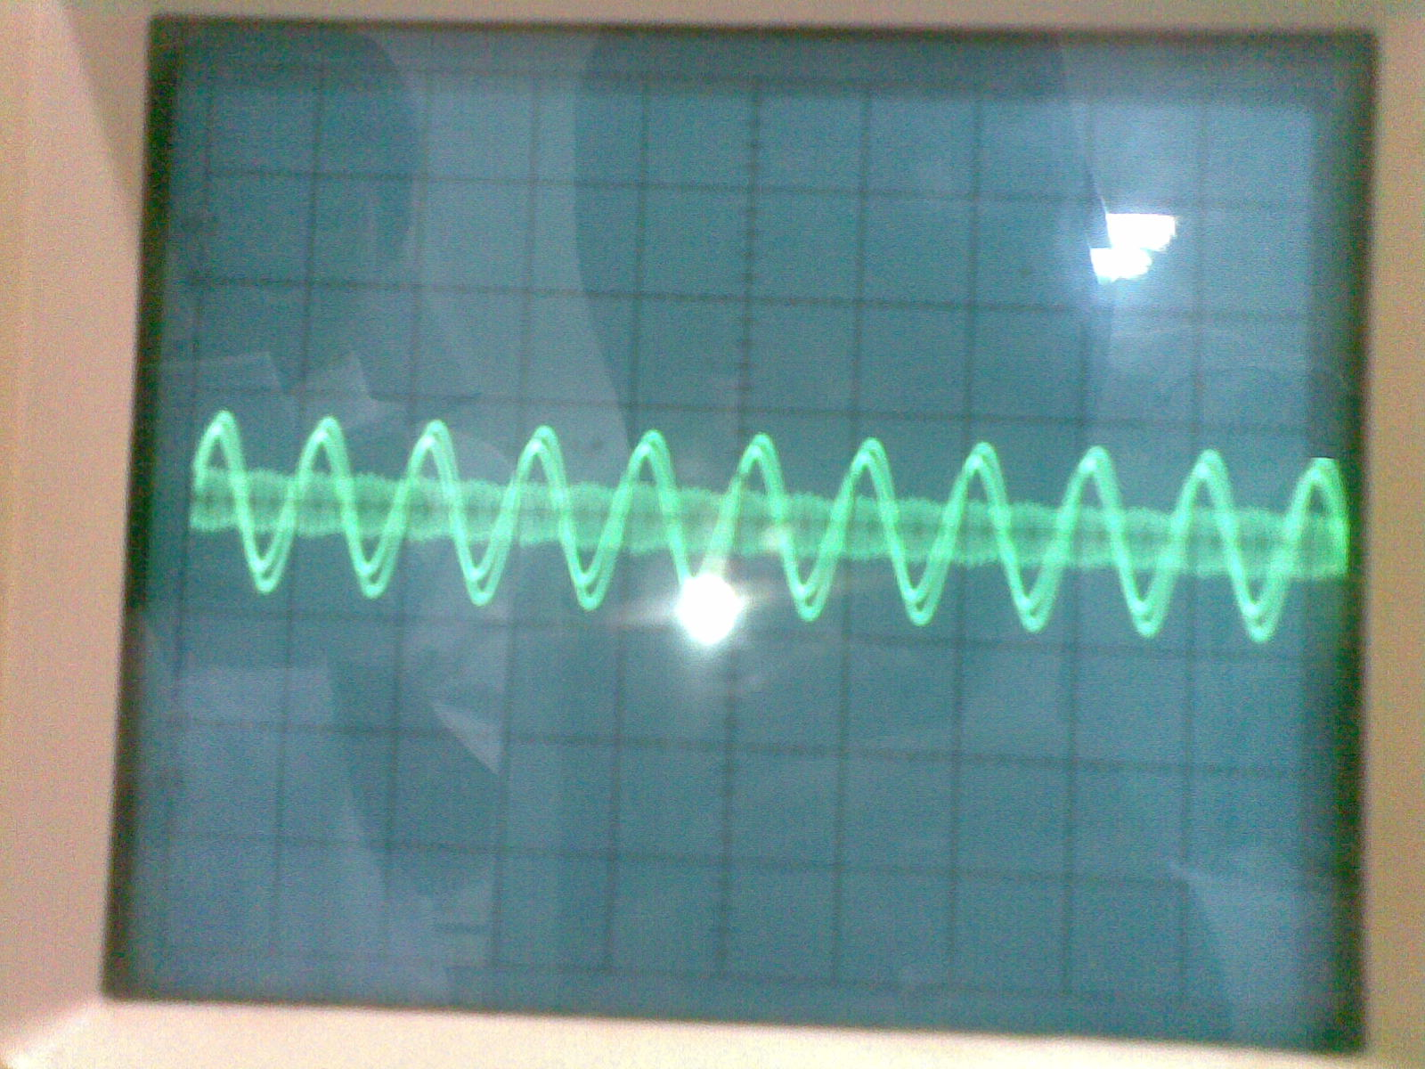
2 | 1 | 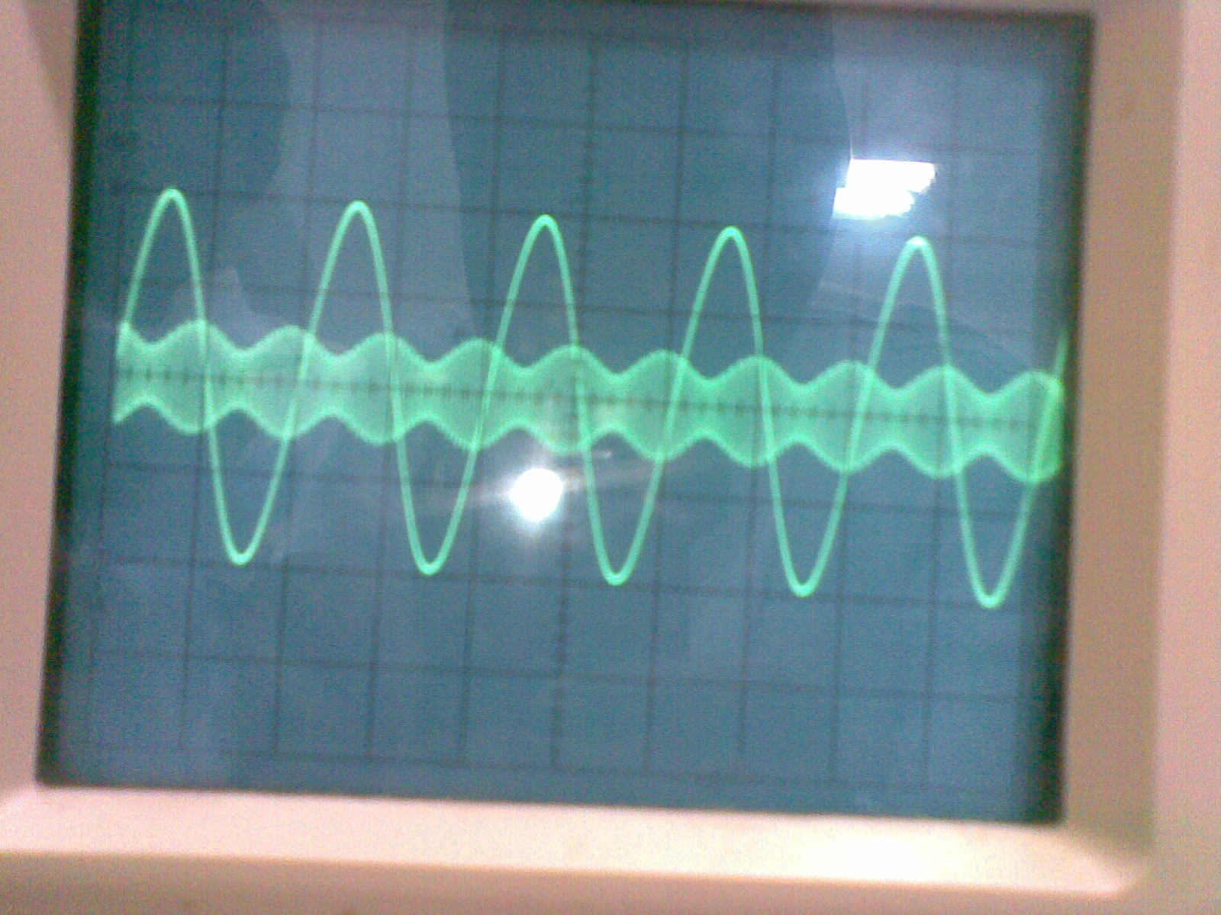
Tabel 12
Percobaan | Fm | Am | $∆$Ac | Ac | m
1 | 2 | 2 | 0.2 | 1.6
2 | 3 | 2 | 0.1 | 1.6
3 | 2 | 3 | 0.2 | 1.6
4 | 2 | 1 | 0.1 | 1.6
5 | 1 | 2 | 0.1 | 1.6
- DEMODULASI SSB
  - SWITCH ON CARRIER
AREA 1
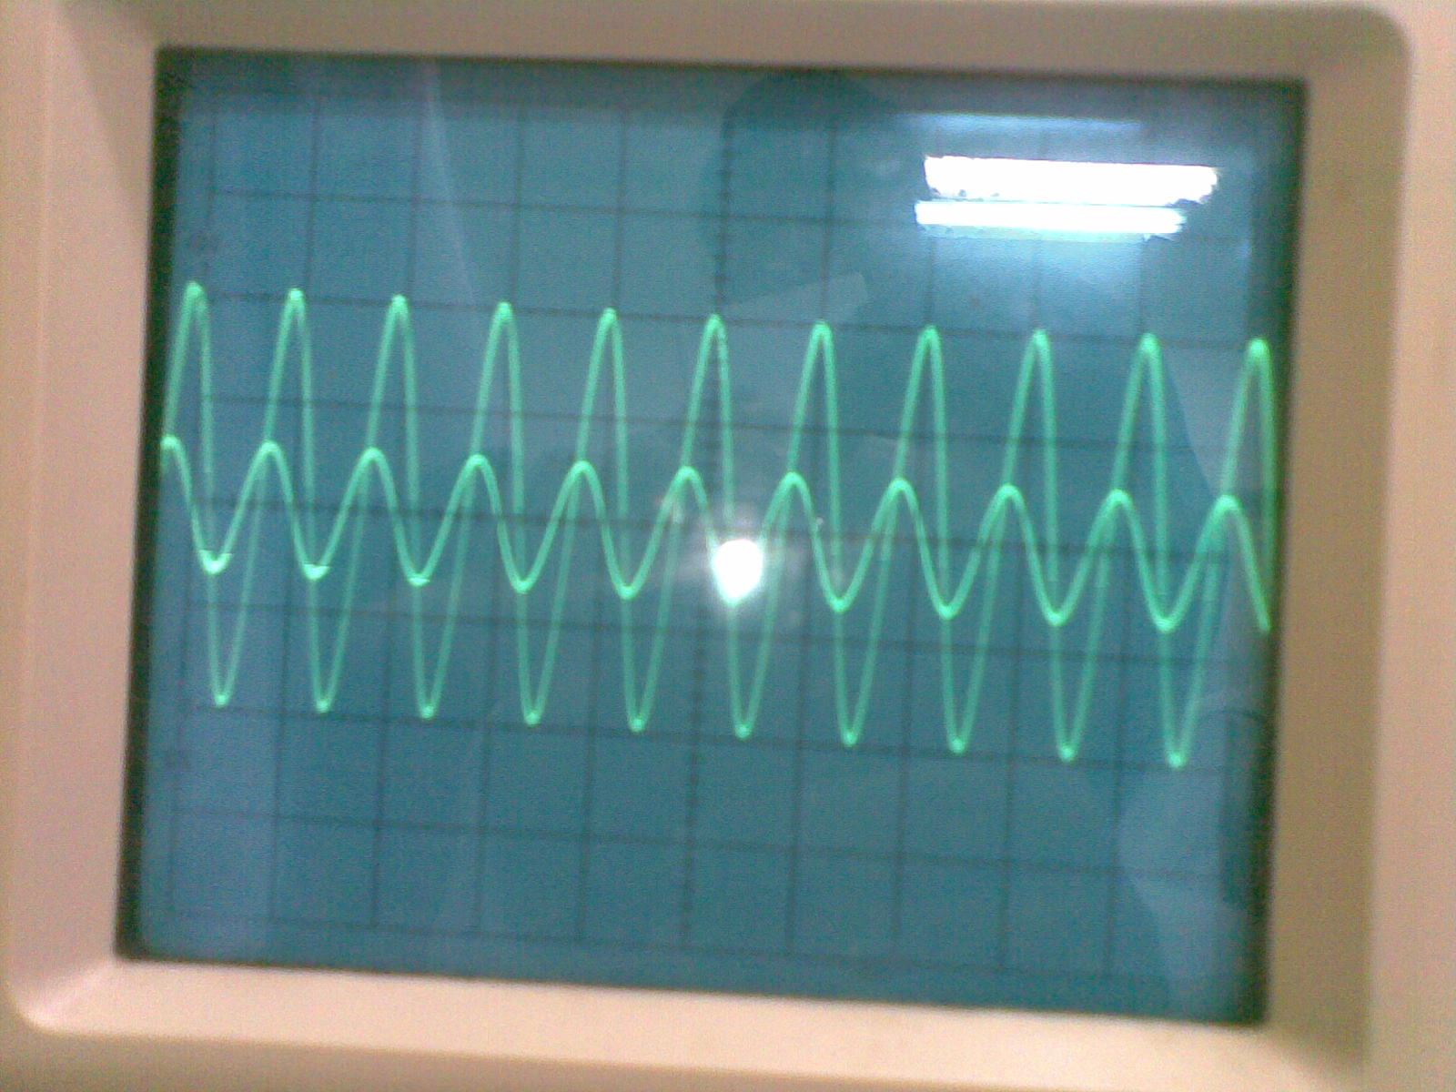

- SWITCH OFF CARRIER
AREA 2
